Assessment, reporting, and the new curriculum

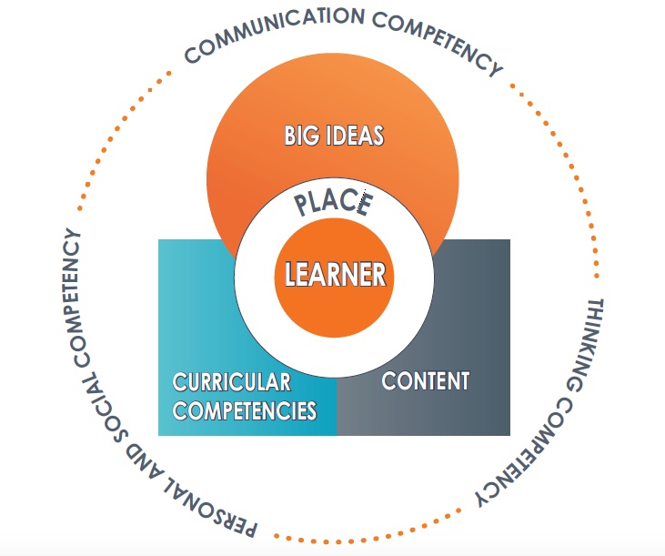

Kevin Sigaty
Teacher Educator
Faculty of Education (Field Programs)
Simon Fraser University
kevin_sigaty@sfu.ca

Research Snapshots on Learning
1
The ability to plan a task, to notice patterns, to generate reasonable arguments and explanations, and to draw analogies to other problems are all more closely intertwined with factual knowledge than was once believed (Bransford, 2000, p.17).

2.
But knowledge of a large set of disconnected facts is not sufficient. To develop competence in an area of inquiry, students must have opportunities to learn with understanding. Deep understanding of subject matter transforms factual information into usable knowledge…. allows them to see patterns, relationships, or discrepancies that are not apparent to the novice (Bransford, 2000, p.17).

3.
Superficial coverage of all topics in a subject area must be replaced with in-depth coverage of fewer topics that allows key concepts in that discipline to be understood. The goal of coverage need not be abandoned entirely, of course. But there must be a sufficient number of cases of in-depth study to allow students to grasp the defining concepts in specific domains within a discipline. Moreover, in-depth study in a domain often requires that ideas be carried beyond a single school year before students can make the transition from informal to formal ideas. This will require active coordination of the curriculum across school years (Bransford, 2000, p.20).

4.
In all domains of learning, the development of expertise occurs only with major investments of time…. to explore underlying concepts and to generate connections to other information they possess. Attempts to cover too many topics too quickly may hinder learning and subsequent transfer because students (a) learn only isolated sets of facts that are not organized and connected or (b) are introduced to organizing principles that they cannot grasp because they lack enough specific knowledge to make them meaningful (Bransford, 2000, p.58).

5.
A key finding in the learning and transfer literature is that organizing information into a conceptual framework allows for greater “transfer”; that is, it allows the student to apply what was learned in new situations and to learn related information more quickly (Bransford, 2000, p.17).

Research has indicated that transfer across contexts is especially difficult when a subject is taught only in a single context rather than in multiple contexts (Bjork and Richardson-Klavhen, 1989). When a subject is taught in multiple contexts, however, and includes examples that demonstrate wide application of what is being taught, people are more likely to abstract the relevant features of concepts and to develop a flexible representation of knowledge (Gick and Holyoak, 1983).
Simple Machines Unit

Do all simple machines make work easier? Which simple machine is the most efficient?
Could you design a simple machine to help someone with physical challenges?

Steps

- Demonstrate example of machine that uses multi-pulley system (eg. Elevator, theater curtain)—introduce some associated vocabulary

- Solicit questions (what are these? What do they do? Why?)—teach different question frames, practice

- Introduce concept of work and simple machines (a few examples)—introduce associated vocabulary and initiate brainstorming about types of simple machines with focus on new vocab

- Students find examples of simple machines in classroom, school and outside (in groups, maybe scavenger hunt style)—review language needed for collaboration, directions, outside, searching---practice

- Students theorize (language about theorizing, suggesting, justifying---practice)
  - which devices from examples found might be simple machines
  - What “work” is made easier
  - Why do you think that?

- Teacher helps students confirm or reject theories (seminar groups)

- Students experiment with simple machines and work measurement devices provided by teacher (play, exploration)

- Assign problem: Do all simple machines reduce work? Which simple machine is the most efficient?

- Teach (concepts and vocab)
  - Multiple examples of simple machines
  - Defining “work” and provide examples
  - Measuring (and calculating) “work”

- Students attempt to design experiment in groups (some basic language about experiments--practice)

- Teacher provides info on scientific method, students review their procedure (with teacher support) to revise with scientific method in mind (more specific language about scientific method--practice)

- Teacher approves procedure, students begin (reviewing necessary language for collaboration, data, equipment etc.)

- Students gather and interpret data with teacher support (review lang hypothesizing, justifying)

- Students develop and communicate conclusion (teacher reviews)

- Using the knowledge from this process, students will attempt to design machine designed to help someone participate in PE who may have physical challenges (should need to call upon language from earlier phases of unit in discussion and written communication)
  - Collaboration
  - Some exploration of physical challenges some people face
  - Include experimentation with design (with materials, technology, digital apps, lego, etc.)
  - Try things out—consider alternatives
  - Design machine and explain the principles involved
  - Build

  - Showcase

The French Revolution
Why are some people satisfied with the societal status quo while others wish to make change?
Is it sometimes right to engage in civil disobedience or revolution? Under what circumstances?
What conditions might lead to a revolution? To what extent is it preventable, and to what extent should it be prevented?
What do you feel are the civic duties of government and the governed? Why?
It is 1789 and the political, economic, and social situation in France is unstable. Revolution is brewing. Students individually need to decide whether to rise up against the crown in revolution (having examined the situation in France) and persuade others of their view. Revolution is dangerous, but is it worth it? Students could be assigned a role (eg peasant, artisan, soldier, noble, clergy) as a lens to examine the conditions. They would need to persuade others of their decision to rebel or not.
To do this they would need to
- examine the underlying conditions in France
- consider the economic, political, religious, social and identity issues from different perspectives
- adopt the perspective of their role (they could even have names)
- consider possible outcomes by looking at other revolutions (successful and unsuccessful) for comparison, but in less detail (eg. Jacobite Rebellion, American Revolution, Hatian Revolution)
- develop and use ideas to support their position
Perhaps do not tell the students whether the revolution actually happened or what the outcome was until the end, where you take them through the events of the rebellion. Students that decided not to rebel could be seen as traitors to the revolution and be "executed" by Robbespierre at the guillotine (how fun would that be?).
There would be a mix of reading, writing, and verbal interaction, all of which with the purpose to either understand the issues in order to make a decision, or to persuade others to make a certain decision. This could be a mix of individual, group, and whole class activities. Writing could involve "correspondence" (paper or electronic) asking others what they think, or try to persuade or threaten. Or it could be a "journal" pondering the decision, maybe talking about their current thinking and what more they need to know (reflective writing and assessment possibilities). Group discussions could involve the same thing.
Final decisions could be announced at a joint meeting of the Estates General (prior to the tennis court oath). Then you could take them through the events of the French Revolution and let the executions begin.

Possible Steps in Project
- Determine what students know about French Revolution, revolutions in general etc. in groups while observing group interactions
- Introduce project

- Examine the concept and importance of civic responsibility
  - including local and present day contexts, as well as historical
  - consider why one might engage in civil disobedience or rebellion.
  - Student reflective writing: a response to discussion, expressing their opinion and whether opinion shifted at all during the activity

- Brainstorm why people in different roles in modern society might have different perspectives on things (examine modern debates on politics, taxes, land use etc.)

- Examination of the French context circa 1780s
  - political structure in France
  - economic, religious, social and cultural issues and tensions
  - including printed sources, direct instruction, discussion and debate

- Perspective taking
  - adopt roles from French society
  - determine likely points of view on social and economic conditions and societal upheaval (student collaboration)
  - small group meeting with teacher for feedback on reasonableness of point of view
  - is there a particular group that is oppressed during this time? Justify.

- Examine conflicting “ideologies” from the time with respect to the current situation and tensions in France---students may adopt or revise perspectives or points of view of French situation in 1780s (students discuss personal experiences, historical examples from France circa 1780s).

- Students communicate to teacher which “side” they pick on a preliminary basis, and justify their choice using historical evidence and perspective

- Pre-revolution
  - Students attempt to convince others of their perspective on the situation in France.
  - Students Lobby, persuade, threaten others to persuade to their point of view/cause
  - student interactions at stations or other “meeting places”
  - monitored written interaction (paper or electronic)
  - persuasion using historical evidence
  - Student written response: examination of arguments presented to them and whether they are shifting position and why.
- Other revolutions as case studies
  - Students examine case studies of other revolutions for guidance, understanding possible contexts, causes and consequences, tactics:
  - examples including Jacobite Rebellion, American Rev, Hatian Rev, Metis resistance
  - students communicate to teacher how these different case studies inform their thinking, teacher provides feedback on thinking
- Students declare their intentions at the Estates General for the revolution and justify them

- Revolution Begins and Ends
  - Rebels plan revolt, Crown forces plan defense
    - role play, strategy share, nerf gun or “game board” reenactment
    - Neutral party (teacher, maybe a few uncommitted students) referee and determine likely victor in scenario presented by students
    - Debrief
    - Examine events, outcome, and key people of revolution (printed sources, direct instruction, video etc.)
    - Based on historical results, “execute” members of crown forces and members upper classes…reenacting (while examining) the purges taking place during the rein of terror
  - Examine consequences of revolution
    - Was it worth it?
    - Was it right?
    - To what extent was the reign of terror inevitable and necessary?
    - How significant was it?
    - Weigh historical evidence and personal ethical judgment

- What did you learn? Provide evidence. (demonstration of learning in multiple formats). Possible themes:
  - How did the scenario compare with real historical events?
  - Which historical figures did their “character” most identify with? Who did they personally most identify with? Why?
  - Review previous writings and reflections: would you change anything?
  - Why are some people satisfied with the societal status quo while others wish to make change?
  - Is it sometimes right to engage in civil disobedience or revolution? Under what circumstances?
  - What conditions might lead to a revolution? To what extent is it preventable, and to what extent should it be prevented?
  - What do you feel are the civic duties of government and the governed?
  - What else did you learn from this?
  - Celebration
  - Possible follow up: Revisit ideas of civic duty, create constitution designed to ensure political, economic, and social stability (see part 2)
The French Revolution (Part 2) The Making of a Modern Nation-State
A part 2 could be after the revolution. Those of your students who joined the revolution and weren't executed are now trying to form a new gov't as members of the assembly. Those that didn't survive need new identities. In groups, they could try to develop a new vision of how the country should be run. Once achieving consensus, each group will then articulate their vision in the form of a draft constitution. A model could be the Canadian Charter of Rights and Freedoms and the Constitution). Each group could share their draft constitution with others, and the class would need to decide on one for the whole class. This allows you to explore different ideas about gov't, rights and freedoms and responsibilities etc. And again you could look at what actually happened at the end. Some time could be spent talking about what is meant by a "modern nation-state" and compare the French experience with that of other countries. Questions leading into subsequent units could be suggested here (why was the establishment of some modern nation-states so violent while others ie. Canada, was not).

